

 

# DESIGN AND FABRICATION OF AUTOMATIC CANCRUSHER MACHINE

**A PROJECT REPORT**

***Submitted by***

**CHANAKYAN .J (927622 BME 010 )**

**BHUPESH .P (927622 BME 009 ) GOPALAKRISHNAN.M ( 927622BME302)**

***in partial fulfillment for the award of the degree***

***of***

BACHELOR OF ENGINEERING

**IN**

# MECHANICAL ENGINEERING

**M.KUMARASAMY COLLEGE OF ENGINEERING, KARUR**

ANNA UNIVERSITY: CHENNAI 600 025

# NOV 2023

 

# DESIGN AND FABRICATION OF AUTOMATIC CAN CRUSHER MACHINE

**A PROJECT REPORT**

***Submitted by***

**CHANAKYAN .J (927622 BME 010 )**

**BHUPESH .P (927622 BME 009 ) GOPALAKRISHNAN.M ( 927622BME302)**

***in partial fulfillment for the award of the degree of***

**BACHELOR OF ENGINEERING**

***in***

MECHANICAL ENGINEERING

# M.KUMARASAMY COLLEGE OF ENGINEERING, KARUR

ANNA UNIVERSITY: CHENNAI 600 025

# NOV 2023

M.KUMARASAMY COLLEGE OF ENGINEERING, KARUR

BONAFIDE CERTIFICATE

Certified that this project report "**DESIGN AND FABRICATION OF AUTOMATIC CAN CRUSHER MACHINE"** is the bonafide work of "**CHANAKYAN.J (927622BME010), BHUPESH.P (927622BME009) ,GOPALAKRISHNAN.M ( 927622BME302)"** who carried out

the project work during the academic year 2023 – 2024 under my supervision. Certified further, that to the best of my knowledge the workreported herein does not form part of any other project report or dissertation on the basis of which a degree or award was conferred on an earlier occasion on this or any other candidate.

**SIGNATURE SIGNATURE**

Dr. M. MOHAN PRASAD M.E., MBA., Ph.D. Dr. G.R.GOPINATH M.E., Ph.D.

**HEAD OF THE DEPARTMENT SUPERVISOR**

Department of Mechanical Engineering, Department of Mechanical Engineering,

M.Kumarasamy College of Engineering, M.Kumarasamy College of Engineering,

Thalavapalayam, Karur-639113. Thalavapalayam, Karur-639113.

This project report has been submitted for the end semester project viva voce Examination held on

INTERNAL EXAMINER EXTERNAL EXAMINER

DECLARATION

We affirm that the Project titled **“DESIGN AND FABRICATION OF AUTOMATIC CAN CRUSHER MACHINE”** being submitted in partial fulfillment of for the award of Bachelor of Engineering in Mechanical Engineering, is the original work carried out by us. It has not formed the part of any other project or dissertation on the basis of which a degree or award was conferred on an earlier occasion on thisor any other candidate.

Student name

# CHANAKYAN.J

**BHUPESH.P**

# GOPALAKRISHNAN.M

Signature

---------------------------

----------------------------

----------------------------

Name and signature of the supervisor with date

# ACKNOWLEDGEMENT

Our sincere thanks to Thiru. M. Kumarasamy, Chairman and Dr. K. Ramakrishnan, B.E, Secretary of M. Kumarasamy College of Engineering for providing extra ordinary infrastructure, which helped us to complete the project in time.

It is a great privilege for us to express our gratitude to our esteemed Principal Dr.B.S. Murugan M.E., Ph.D. for providing us right ambiance for carrying out the project work.

We would like to thank Dr.M. Mohan Prasad M.E, MBA., Ph.D, Head, Department of Mechanical Engineering, for their unwavering moral support throughout the evolution of the project.

We offer our whole hearted thanks to our internal guide Dr. G.R.Gopinath M.E., Ph.D., Professor, Department of Mechanical Engineering, for her/his constant encouragement, kind co-operation, valuable suggestions and support rendered in making our project a success.

We offer our whole hearted thanks to our project coordinator Mr.S. Raja Narayanan M.E., Department of Mechanical Engineering, for her/his constant encouragement, kind co-operation, valuable suggestions and support rendered in making our project a success.

We glad to thank all the Teaching and Non-Teaching Faculty Members of Department of Mechanical Engineering for extending a warm helping hand and valuable suggestions throughout the project.

Words are boundless to thank Our Parents and Friends for their constant encouragement to complete this project successfully.

# INSTITUTION VISION & MISSION

**Vision**

* To emerge as a leader among the top institutions in the field of technical education.

# Mission

* Produce smart technocrats with empirical knowledge who can surmount the global challenges.
* Create a diverse, fully-engaged, learner-centric campus environment to provide quality education to the students.
* Maintain mutually beneficial partnerships with our alumni, industry and professional associations.

# DEPARTMENT VISION, MISSION, PEO, PO & PSO

**Vision**

* To create globally recognized competent Mechanical engineers to work in multicultural environment.

# Mission

* To impart quality education in the field of mechanical engineering and to enhance their skills, to pursue careers or enter into higher education in their area of interest.
* To establish a learner-centric atmosphere along with state-of-the-art research facility.
* To make collaboration with industries, distinguished research institution and to become a centre of excellence

# PROGRAM EDUCATIONAL OBJECTIVES (PEOS)

The graduates of Mechanical Engineering will be able to

* PEO1: Graduates of the program will accommodate insightful information of engineering principles necessary for the applications of engineering.
* PEO2: Graduates of the program will acquire knowledge of recent trends in technology and solve problem in industry.
* PEO3: Graduates of the program will have practical experience and interpersonal skills to work both in local and international environments.
* PEO4: Graduates of the program will possess creative professionalism, understand their ethical responsibility and committed towards society.

# PROGRAM OUTCOMES

**The following are the Program Outcomes of Engineering Graduates:Engineering Graduates will be able to:**

1. **Engineering knowledge:** Apply the knowledge of mathematics, science, engineering fundamentals, andan engineering specialization to the solution of complex engineering problems.
2. **Problem analysis:** Identify, formulate, review research literature, and analyze complex engineering problems reaching substantiated conclusions using first principles of mathematics, natural sciences, and engineering sciences.
3. **Design/development of solutions:** Design solutions for complex engineering problems and design systemcomponents or processes that meet the specified needs with appropriate consideration for the public healthand safety, and the cultural, societal, and environmental considerations.
4. **Conduct investigations of complex problems:** Use research-based knowledge and research methods including design of experiments, analysis and interpretation of data, and synthesis of the information to provide valid conclusions.
5. **Modern tool usage:** Create, select, and apply appropriate techniques, resources, and modern engineeringand IT tools including prediction and modeling to complex engineering activities with an understanding of the limitations.
6. **The engineer and society:** Apply reasoning informed by the contextual knowledge to assess societal, health, safety, legal and cultural issues and the consequent responsibilities relevant to the professional engineering practice.
7. **Environment and sustainability:** Understand the impact of the professional engineering solutions in societal and environmental contexts, and demonstrate the knowledge of, and need for sustainabledevelopment.
8. **Ethics:** Apply ethical principles and commit to professional ethics and responsibilities and norms of the engineering practice.
9. **Individual and team work:** Function effectively as an individual, and as a member or leader in diverse teams, and in multidisciplinary settings.
10. **Communication:** Communicate effectively on complex engineering activities with the engineering community and with society at large, such as, being able to comprehend and write effective reports and design documentation, make effective presentations, and give and receive clear instructions.
11. **Project management and finance:** Demonstrate knowledge and understanding of the engineering and management principles and apply these to one’s own work, as a member and leader in a team, to manage projects and in multidisciplinary environments.
12. **Life-long learning:** Recognize the need for, and have the preparation and ability to engage in independentand life-long learning in the broadest context of
13. technological change.



**PROGRAM SPECIFIC OUTCOMES (PSOs)**

**The following are the Program Specific Outcomes of Engineering Graduates:** The students will demonstrate the abilities

* 1. **Real world application:** To comprehend, analyze, design and develop innovative products and provide solutions for the real-life problems.
  2. **Multi-disciplinary areas:** To work collaboratively on multi-disciplinary areas and make quality projects.

**Research oriented innovative ideas and methods:** To adopt modern tools, mathematical, scientific and engineering fundamentals required to solve industrial and societal problems

|  |  |  |
| --- | --- | --- |
| **Course Outcomes** | At the end of this course, learners will be able to: | **Knowledge Level** |
| CO-1 | Identify the issues and challenges related to industry, society and environment. | Apply |
| CO-2 | Describe the identified problem and formulate the possible solutions | Apply |
| CO-3 | Design / Fabricate new experimental set up/devices to provide solutions for  the identified problems | Analyse |
| CO-4 | Prepare a detailed report describing the project outcome | Apply |
| CO-5 | Communicate outcome of the project and defend by making an effective oral presentation. | Apply |

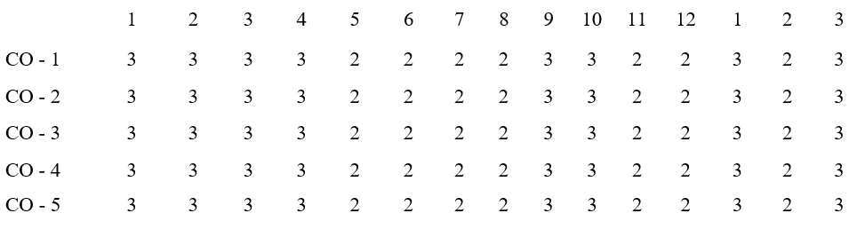

**MAPPING OF PO & PSO WITH THE PROJECT OUTCOME**

**Program**

**Course**

**Outcomes**

**ProgramOutcomes**

**Specific**

**Outcomes**



# TABLE OF CONTENTS

|  |  |  |
| --- | --- | --- |
| **CHAPTER NO.** | **CONTENT** | **PAGE NO.** |
|  | ABSTRACT | 1 |
|  | SCOPE OF THIS PROJECT | 2 |
| 1 | INTRODUCTION | 3 |
| 2 | WORKING | 5 |
| 3 | MATERIALS | 6 |
| 3.1 | BATTERY | 6 |
| 3.2 | PNEUMATIC CYLINDER | 7 |
| 3.3 | PROXIMITY SENSOR | 7 |
| 3.4 | GEAR DRIVE | 7 |
| 3.5 | COST ESTIMATION | 8 |
| 4 | DESIGN FOR DOMESTIC PURPOSE | 9 |
| 4.1 | DESIGN FOR INDUSTRIAL PURPOSE | 10 |
| 5 | WORKING PRINCIPLE | 11 |
| 5.1 | USES | 11 |
| 5.2 | ADVANTAGES | 11 |
| 6 | REFERENCE | 12 |

**ABSTRACT**

An automatic can crusher is a product that fulfils customer needs . This project uses many materials such as sheet metal , hollow steel bar and others . The pneumatic system and a microcontroller make up the backbone for this project.

Overall , this project involves processes like design, fabrication and assembling procedures . Even though there are many types of the can crusher machine in the market, the completion of this new model provides a more practical usage.

A can crusher can be defined as “A device used for crushing aluminum cans for easier storage in recycling bins thereby giving you extra space by flattening of cans”.

Pneumatics is a section of technology that deals with the study and application of pressurized gas to produce mechanical motion.

In autonomous mode the pneumatic system , microcontroller and sensor system work in unison to successfully crush the cans while in assistive mode, the pneumatic system can be manually operated.

The project incorporates the study of pneumatic systems, Computer Aided Design software‟s and microcontroller.

.

The main aim of a can crusher is to smash an empty aluminum can into the smallest unit possible. Anyone who drinks a couple of sodas a week may never see the need to compact the cans, but others who are heavy drinkers may find these devices very helpful. Canteens, restaurants, bars, catering halls, cinema halls and recycling plants are places where a can crusher is pretty much a must.

**Why to Recycle?**

Aluminum doesn ‟t occur naturally in the earth ‟s crust , it has to be extracted from its ore – bauxite – which is mined and then smelted in a very energy-intensive process. Although great care is taken to rebuild the land after mining, changes do occur as a result of mining that are detrimental to the surrounding environment. It takes 80-100 years for aluminum can to decompose.

Compared to mining and smelting, recycling aluminum drink cans is far less energy intensive

. Recycling aluminum requires only 5% of the energy and produces only 5% of the CO 2 emissions as compared with primary production. A recycled aluminum can saves enough energy to run a television for three hours. More than 100 billion aluminum cans are sold in the

United states each year, but less than half are recycled. A similar number of aluminum cans in other countries are also incinerated. Aluminum cans are one of the easiest materials to recycle. New drinks cans appear on the shelf just six weeks after recycling. A single aluminum can is said to, when recycled, saves about as much as oil as would be poured into it to fill up

1. **INTRODUCTION**

# CHAPTER-1

This project consists of designing and fabrication of an automatic can crusher. In order to reduce the waste, we planned to create a can crusher that will reduce the volume of aluminum cans by eighty percent. Can crushers are primarily used to save

space and for recycling. It can be placed everywhere, in the park, restaurants, canteens etc. This project needs skills, information and knowledge of Computer Aided Design softwares like AutoCAD and Solidworks, use of laser cutting machine, Truma Bend V Series(bending machine), shearing machine, vertical bend saw, bench work and welding processes.

A can crusher can be defined as “A device used for crushing aluminum cans for easier storage in recycling bins thereby giving you extra space by flattening of cans”.

Different types of existing can crushers:

3

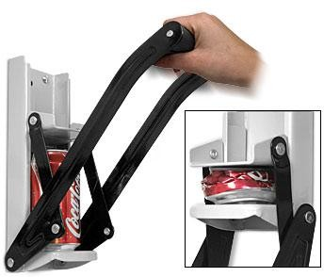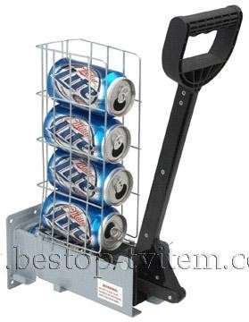

Manual single can crusher

Manual single can crusher

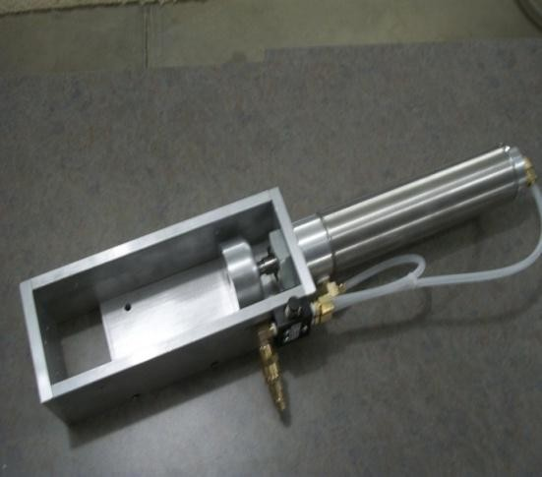

turbine to produce energy. Portable generator was also developed by [11] by using a polymer electrolyte membrane fuel cell (PEMFC). This prototype could generate energy up to 500 Watt per hour at temperature between 60-80 °C. Designed a portable generator based on a chemical reaction from micro direct ethanol fuel cell (Micro- DEFC). The result of this study showed that the chemical reaction produces electricity reaching 0.9 mV and this chemical reaction depends on temperature. All these studies focus only on the design of portable generator in producing energy regardless of users’ requirements in use. The objective of this study was to redesign the portable hydroelectric generator to have a more effective, more efficient and safer generator by using axiomatic design method. Energy is classified into the main needs of the Indonesian people. Indonesia has several problems in the energy sector, including increasing energy consumption, high dependence on fossil energy, and low electrification ratio. A portable hydropower system needs to be developed in remote areas to meet the needs of electrical energy. The power plant can utilize the energy stored in the running water which is known as a Nano-hydro power plant. The power plant can operate using slow-flowing rivers. The kinetic energy stored in the flowing water can also be used to generate electricity. The changing seasons will cause fluctuations in river water discharge so that the energy produced will fluctuate. The development of portable Nano-hydro power generators by the community will encourage the use of natural resources more effectively and efficiently. The variation of turbine speed will occur in a standalone hydropower plant due to variations in the connected load. It will change the generator voltage so that a control equipment is needed to regulate the voltage. The river flow turbine will start working when water enters the turbine. The water is directed by the guiding angle towards the runner and exits through a draft tube. The runner will rotate due to the kinetic energy of the water so that the turbine shaft will rotate. The generator coupled to the turbine will generate voltage at the output terminal. This type of water turbine is suitable for application in flat rivers and irrigation channels.

1. **WORKING**

# CHAPTER-2

The blades where connected with the motor. The blades are kept under the water drain and the force of water rotates the gear drive. The gear drive gives multiple rotations in the dc motor. The increase in force increases the electricity production. The electricity can be stored in battery. In high level industries the power can be consumed directly from the output. In a large amount of water is available or you can say a well. The water is being stored in the reservoir which is in the form of potential energy. With the use of the control gate, the water is being released and water starts flowing into the penstock. Initially, the valve is closed. But when the water reaches up to the max level that can create high pressure then we on the valves. The water with high pressure starts flowing and strikes to the turbine blades.

In the turbine blade, an electric motor is attached to the turbine shafts. So rotation of turbine blades also rotates the turbine shafts, which also rotates the electric motor. Hence Kinematic energy into mechanical energy and then further it is converted into electric energy. The potential energy stored in the water of the reservoir stored at a higher level will release as kinetic energy as it falls to the lower level. Water from the reservoir will be made to fall on the turbine in such a way that the force due to the waterfall will result in rotating the turbine. The turbine is further connected to the generator, then the generator will generate electricity. The electricity produced is also known as the hydroelectric current or hydropower. This is how hydroelectric power plants work and hence produce electricity which is further transmitted through transmission lines as per the need.

1. **MATERIALS**

Materials Used:

BATTERY

# CHAPTER-3

PNEUMATIC CYLINDER PROXIMITY SENSOR METAL FRAMES

**3.1. BATTERY**

A battery is a source of electric power consisting of one or more electrochemical cells with external connections .for powering electrical devices. When a battery is supplying power, its positive terminal is the cathode and its negative terminal is the anode the terminal marked negative is the source of electrons that will flow through an external electric circuit to the positive terminal. When a battery is connected to an external electric load, a redox reaction converts high-energy reactants to lower-energy products, and the free-energy difference is delivered to the external circuit as electrical energy. Historically the term "battery" specifically referred to a device composed of multiple cells; however, the usage has evolved to include devices composed of a single cell.

PNEUMATIC CYLINDER

Pneumatic cylinder, also known as air cylinder, is a mechanical device which uses the power of compressed gas to produce a force in a reciprocating linear motion. Operation diagram of a single acting cylinder. The spring (red) can also be outside the cylinder, attached to the item being moved. Like in a hydraulic cylinder, something forces a piston to move in the desired direction. The piston is a disc or cylinder, and the piston rod transfers the force it develops to the object to be moved.[1] : 85  Engineers sometimes prefer to use pneumatics because they are quieter, cleaner, and do not require large amounts of space for fluid storage.

7

Because the operating fluid is a gas, leakage from a pneumatic cylinder will not drip out and contaminate the surroundings, making pneumatics more desirable where cleanliness is a requirement. For example, in the mechanical puppets of the Disney Tiki Room, pneumatics are used to prevent fluid from dripping onto people below the puppets.

PROXIMITY SENSOR

A proximity sensor often emits an electromagnetic field or a beam of electromagnetic radiation (infrared, for instance), and looks for changes in the field or return signal. The object being sensed is often referred to as the proximity sensor's target. Different proximity sensor targets demand different sensors. For example, a capacitive proximity sensor or photoelectric sensor might be suitable for a plastic target; an inductive proximity sensor always requires a metal target.[citation needed]

Proximity sensors can have a high reliability and long functional life because of the absence of mechanical parts and lack of physical contact between the sensor and the sensed object.

Proximity sensors are also used in machine vibration monitoring to measure the variation in distance between a shaft and its support bearing. This is common in large steam turbines, compressors, and motors that use sleeve-type bearings.

A proximity sensor adjusted to a very short range is often used as a touch switch

.

**3.5. COST ESTIMATION:**

|  |  |  |
| --- | --- | --- |
| **Components** | **Cost(Rs)** | **Total(Rs)** |
| Dynamo motor | 1200 | 1200 |
| Frame | 600 | 600 |
| Blade | 500 | 500 |
| Battery(12v) | 1200 | 1200 |
| Charging unit | 500 | 500 |
|  | Total(Rs) | 4000 |

1. **DESIGN**

# CHAPTER-4

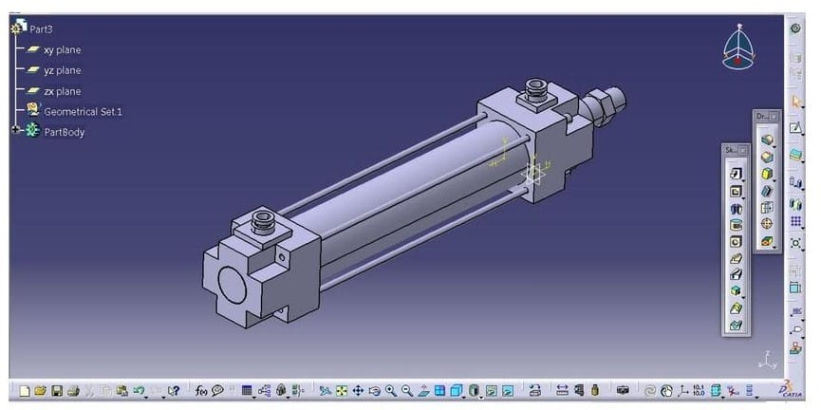

DESIGN OF DOUBLE ACTING PNEUMATIC CYLINDER

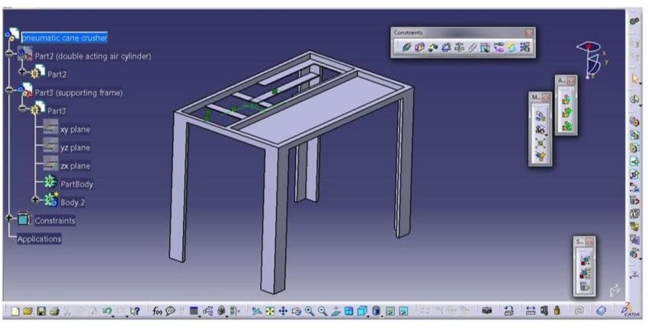

* 1. **DESIGN**

# DESIGN OF FRAME

1. **WORKING PRINCIPLE**

# CHAPTER-5

Can crushing has been used by people for compression of cans after usage for a long time. Crushing cans by bare hands Is a difficult and very strenuous process. So here we propose a pneumatic based can crushing system that allows for fully automated can crushing. This is a very useful system for hotels/restaurants/public places where a large quantity of cans need to be disposed off. The can crusher can automatically hold cans in queue and crush them one at a time. The system uses pneumatic piston in a particular arrangement with supporting frame having vertical holders and can pushing system. The vertical roller based system is used to push cans through the arrangement. Once the cans reach the bottom a sensor detects this and pushes one can at a time through the roller into the crushing chamber . After a can is pushed the electronics system now operates the pneumatic piston . The piston now pushes the can to compress it against the bed mounted on the other side. This helps to achieve desired compression of can . Once this is done the piston pulls back and the system automatically and the compressed can is ejected by the mechanism from the bottom of the machine and next can is pulled in. This ensures efficient compression which helps in easy storage and disposal of cans..

* 1. **USES**

The Can Crusher machine is widely used in beverage industries or in scrap dealers' shop to reduce the volume of

**.** the cans. Consequently, it leads to the reduction of the transportation cost. This machine is primarily used to save space and for recycling. It can be placed anywhere.

**ADVANTAGES**

**The Can Crusher machine is widely used in beverage industries or in scrap dealers' shop to reduce the volume of the cans. Consequently, it leads to the reduction of the transportation cost. This machine is primarily used to save space and for recycling. It can be placed anywhere.**

1. **REFERENCE**

# CHAPTER-6

1. **V. N. Kshirsagar, D. S. K. Choudhary and P. A. P. Ninaw, "An Automatic Can or Plastic Bottle Crusher Machine - A Review," Int. J. Sci. Res. Dev., vol. 2(2), pp. 66–68, 2014.**
2. **M. Fernandes, "A Review on PLC based Automatic Waste Segregator," Int. J. Adv. Res. Comput. Eng. Technol., vol. 5(2), pp. 280–285, 2016.**
3. **G. Bharth, S. K. K, S. C. V, and T. H. Lakshiminarayana, "Pneumatic Three Axis Modern Trailer," Natl. Conf. Recent Adv. Mech. Eng., vol. 4(5), pp. 891–901, 2016.**
4. **A. Ravi K., B. V. Sundeep, C. Sree V., and N. Mathews, "The Principle of Programmable Logic Controller and its role in Automation," Int. J. Eng. Trends Technol., vol. 4(3), pp. 3, 2013.**
5. **A. Patel, A. Wagh, N. Tilekar, S. Thakur, and B. Knowledge, "Cam Follower Can Crusher Vending," Int. J. Res. Eng. Appl. Manag., vol. 2(6), pp. 12–15, 2016.**
6. **D. A. Sawant, M. A. Venkatesh, and R. C. Yeola, "Buckling and Crushing Analysis of Cylindrical Aluminium Cans & Optimizing the Parameters Effecting Crush Strength Using Fem," Int. Res. J. Eng. Technol., vol. 3(6), pp. 3081–3085, 2016.**